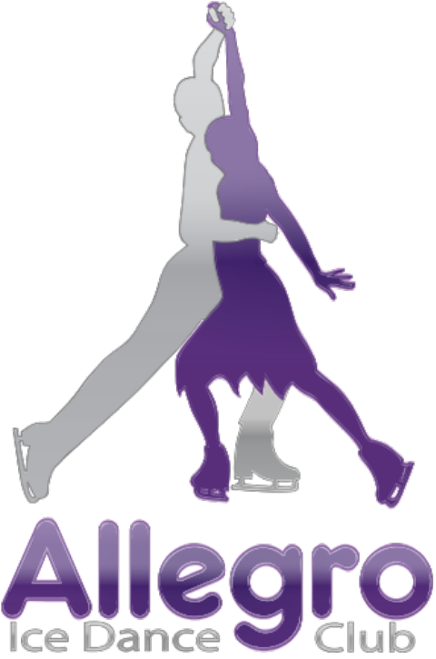

2014
Allegro Ice Dance & Artistic
Competition
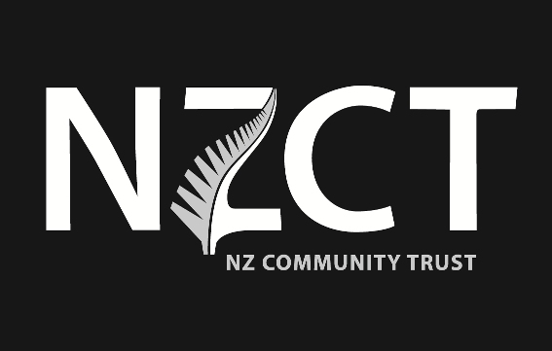


 Version 1.0

2014 Allegro Ice Dance & Artistic Competition Overview
Artistic and Dance Events
Artistic events offer a great opportunity for skaters to work on expression, movement and choreography so important in all disciplines of ice figure skating. Dance events focus on essentials such as edge quality, footwork, timing and expression.

Prizes !! - $100 for the most outstanding performance

Solo Original Dance
One of the fastest growing ice figure skating disciplines, solo dance involves the same elements as pairs dance (compulsory, original and free programmes) with the free programme very similar in nature to the Le Patinage Artistique.

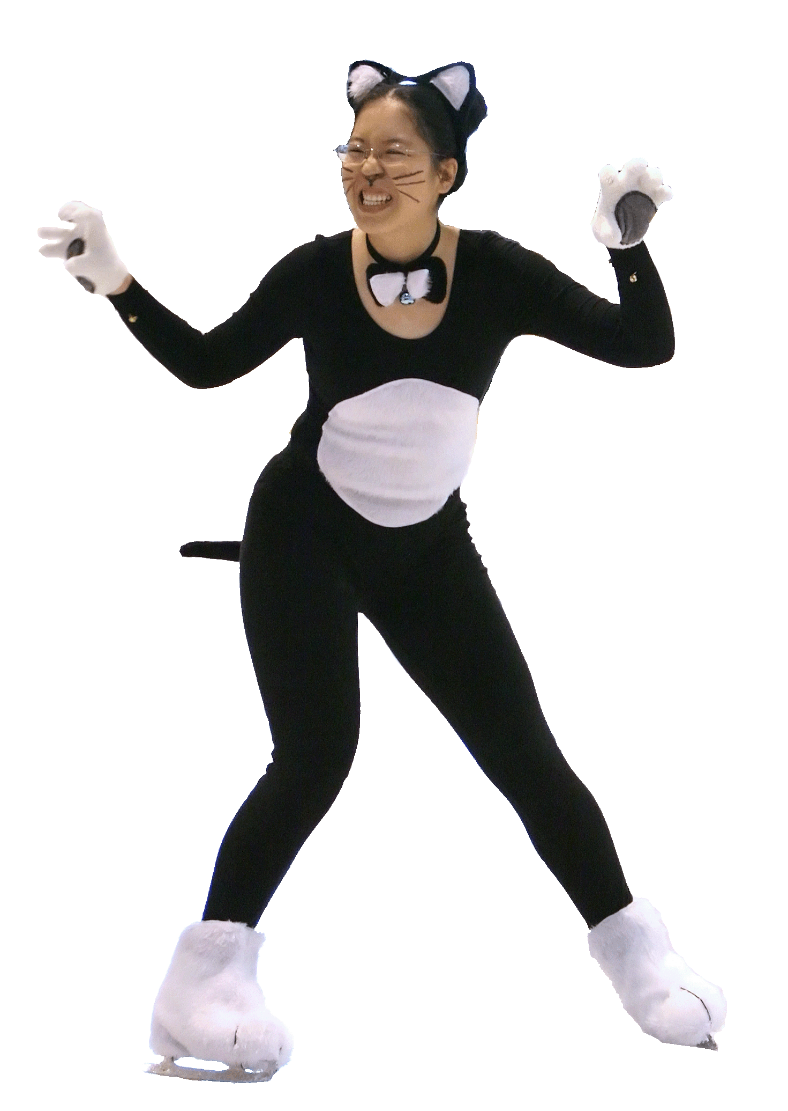

Le Patinage Artistic
This is the classic artistic event set to music of the skater’s choosing which may include vocals. Props are allowed with some restrictions. Choreography and interpretation are all important in this event where jumps count only for their choreographic and interpretive effect.

Theatre on Ice
Theatre on Ice (TOI) is a creation performed by 8 to 30 skaters using all aspects of figure skating, incorporating a theme, emotion or story, enhanced by music. It is a package that includes five dimensions: theme, music/sound, choreography/skating movements, performance/the rapport between the skaters and/or sub-groups of skaters, costuming, props and/or scenery.

Interpretive
Skaters skate to music chosen by the organisers that they will not hear until their warmup. Skaters will not be allowed to hear the music again or watch the performances of skaters who skate before them.

Groups
The Le Patinage Artistique event includes grades for 2 to 20 or more skaters. This is a great opportunity to explore just how much more expressive 2 skaters can be than one. In addition there are Dance and Shadow Dance events.

Skate School
Many of the events, including Le Patinage Artistique are open to skate school students (and other skaters who have not passed any NZISA medal tests). This is a great opportunity to hone your skills and show what you have learned. Ask your coach!

Tiny Tots
For those 6 or under enrolled in the tiny-tots programme. A chance to take centre ice in a relaxed environment. All skaters will skate together with coaches on the ice to take them through the elements.
2014 Allegro Ice Dance & Artistic Competition Information

Date & Time: | Sunday, 7 December 2014 5.15pm to 8.00 pm
Location: | Paradice Botany Downs
Closing Date: | Tuesday, 25 November 2014
Late Entries: | $10 additional fee must accompany application. Applications will be accepted only if space is available. In no case will applications be accepted after the draw on 1 December 2014
Eligibility: | TC registration is required for all events other than Tiny Tots, Skate School divisions, and Theatre on Ice. See event descriptions for other eligibility requirements.
Membership Requirements: | Except for Tiny Tots and Skate School divisions, all NZ entrants must be a member of an NZIFSA affiliated club.
Judging: | Closed marking will be used for all events.
Warm-ups: | Warm up times will be limited to 2 minutes for all events to ensure a fast-running competition.
Draw: | Monday, 1 December 2014. Draw will be done using a random, computerised draw. Results will be available on the NZIFSA website.
Entries: | Entries must be submitted online and all fees paid by direct deposit / internet banking prior to the draw. Bank account details will be provided when you enter online.  Enter online at www.nzifsa.org.nz/competitions/aidc2014 .
Entry Fees:
  Event | Division | Entry Fee
  Tiny Tots ** | Skate School | $10 per skater
  Open Compulsory Dance ** | All divisions | $50 per couple
  Solo Compulsory Dance ** | All divisions | $25 per skater
  Solo Original Dance ** | All divisions | $25 per skater
  Shadow Dance ** | All divisions | $25 per skater
  Interpretive ** | All divisions | $25 per skater
  Le Patinage Artistique ** | Skate School and Pre-Elementary | $20 per skater
  Le Patinage Artistique ** | Synchro (8 or more skaters) | $20 per skater
  Le Patinage Artistique ** | All other divisions | $25 per skater
  Theatre on Ice ** | All divisions | $20 per skater
Refunds: | Any skater who withdraws from their event must notify the organisers as soon as possible. Full refunds will be provided to skaters withdrawing prior to the draw for medical or bereavement reasons. Refunds for other reasons or which are notified after the draw will incur a 25% administration fee and are at the discretion of the committee.
Enquiries: | General: info@icedance.org.nz or 09 309 6226 (Vicki Volkova), or 021 408 920 / 537 0783 (Maureen Forrester)
Prizes! | There is a $100 award for most outstanding performance (as determined by the  judges). Serious performances and skating in time with the music are essential for prize to be awarded. The prize may not be awarded and judges’ decisions are final, no correspondence will be entered into. Note: prize money has no affect on amateur status and is offered to winners regardless of whether they are Allegro Ice Dance Club members or not.
Photo and Video: | Participants agree that the Allegro Ice Dance Club may take photos and videos of them during and around their performances. Participants agree that the Allegro Ice Dance Club may use these in any promotional material.
Announcement  Version: | Version 1.0. Please check the website (www.icedance.org.nz) for changes to the announcement.

2014 Allegro Ice Dance & Artistic Competition Events

MUSIC
All competitors shall provide music on compact disc. This should be given to your coach (to be handed in before the day of the competition) or directly to the organisers prior to the competition. The CD should be clearly labelled with:
Competitor's name,
Event and division (eg. “Junior Dance”, “Le Patinage Artistique, Division K”),
Programme identification (e.g. ”original dance”, if applicable).

EVENTS & ELIGIBILITY
Interpretive (See separate page for details). Skaters in a division will all skate to the same music chosen by the organisers. Skaters will not know the music in advance and will not hear the music until the warm-up. Skaters will not be able to watch other skaters perform.

Le Patinage Artistique (See separate page for details).

Tiny Tots (6 years of age or under)
Skaters to perform a dip (either while skating or standing still), forward skating followed by a two foot glide. Backward skating optional. Skaters will skate together, but may be divided into groups.

Skate School (see Le Patinage Artistique, skate school division). Open to all skaters who have not passed any NZISA medal tests.

Any of the Compulsory Dances below may be skated as a variation, with up to 50% of the segments changed. Couples can be any gender (e.g. male/female, female/female, male/male)

Open Compulsory Dance 1 (couples)
Fiesta Tango (3 sequences)
Open to all dance couples

Open Compulsory Dance 2 (couples)
Foxtrot (2 sequences)
Open to all dance couples

Open Compulsory Dance 3 (couples)
Samba (2 sequences)
Open to all dance couples

Solo Compulsory Dance Level 1
Riverside Rhumba (2 sequences)
Open to all skaters

Solo Compulsory Dance Level 2
Tango (2 sequences)
Open to all skaters

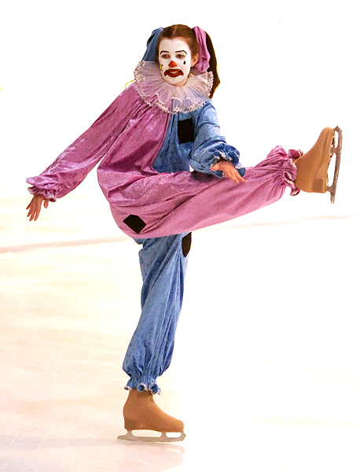

Solo Compulsory Dance Level 3
Starlight Waltz (2 sequences)
Open to all skaters

Solo Original Dance
Tango, Paso Doble, or Waltz music of choice
2 repetitions of an original pattern dance, no jumps, maximum 1 spin (repeated).
Open to all skaters

Shadow Dance (2 or more skaters)
Tango, Blues or Waltz
(2-3 repetitions) of a Tango Blues or Waltz pattern dance – can be original or pattern dance, or variation to a pattern dance). Open to all.

Open Free Dance and Solo Free Dance
There are no specific free dance events. Skaters will compete in the Le Patinage Artistique, Free Dance division(s). (see separate page)
Open to all couples/skaters

Open Pairs
There are no specific pairs events. Skaters will compete in the Le Patinage Artistique, two skaters only division(s). (see separate page)
Open to all pairs

Allegro Le Patinage Artistique - Rules and Guidelines
Le Patinage Artistique is an event where artistry, choreography and interpretation are paramount. Props and costumes may be used to develop a theme. The skater chooses the music (which may include vocals) and develops a programme.

Eligibility The artistic programme is open to many divisions of skaters:
Division A Single Skaters – Skate School and Pre-elementary
Division B1 Single Skaters – Elementary under 14 **
Division B2 Single Skaters – Elementary 14 and over, Juvenile, Pre-primary under 12 **
Division C Single Skaters – Pre-primary 12 and over, Primary, Intermediate **
Division D Single Skaters – Novice, Junior **
Division E Single Skaters – Senior **
Division F Single Skaters – Free Dance, no jumps allowed, maximum one spin allowed
Division X Single Skaters – Adult age 20 or over
Division S Special Olympics – Skater may skate with coach or another skater
Division G Two skaters only – Skate School and Pre-elementary
Division H Two skaters only – Elementary, Juvenile, Pre-primary under 12 **
Division I Two skaters only – Pre-primary 12 and over, Primary, Intermediate **
Division J Two skaters only – Novice, Junior, Senior **
Division K Two skaters only – Free Dance, no jumps allowed, maximum one spin allowed
Division Y Two skaters only – Adult age 20 or over
Division L Groups of 3 to 9 – Skate School and pre-elementary
Division M Groups of 3 to 9 – Elementary, Juvenile **
Division N Groups of 3 to 9 – Pre-primary to Senior **
Division O Groups of 3 to 9 – Free Dance, no jumps allowed, maximum one spin allowed
Division Z Groups of 3 to 9 – Adult age 20 or over
Division Synchro Groups of 8 or more – Open division for all levels

Divisions may be split or combined (by age and/or NZIFSA singles divisions) depending on entries.
** Eligibility of skater under NZIFSA rules for singles. For two or more skaters, the highest level applies. If there are more than 4 (NZIFSA singles) grades between lowest and highest level skaters in a group, the groups may choose to skate down one division. Age is as at 30 June preceeding the competition.

Programme Requirements
Duration Division A,B1,B2,F,G,K,S 1 min 30 seconds +/- 30 seconds
Division C,D,E,H,I,J,L,M,N,O,X,Y,Z 1 min 45 seconds +/- 30 seconds
Division Synchro 3 min +/- 2 min

Programme The interpretive program consists of a variety of skating moves selected for their value in enhancing the skater's interpretation of the music and artistry rather than for their technical difficulty. Triple and double jumps are not permitted. Single jumps (including the Axel Paulsen) and jump-like movements of not more than one revolution and spins are permitted. Credit for jumps and spins will be based solely on their choreographic effectiveness. The program should be an integrated exploration of the chosen music, not merely a collection of pleasing or spectacular moves assembled to entertain an audience with emphasis still being placed on skating skills. In Free Dance divisions, no jumps are allowed and a maximum of one spin is allowed.
Props Props are not permitted except as they are necessary to develop the theme. For example, a top hat and cane would be appropriate in a white tie and tails number as would a veil in Salome's dance. In general, props must be a logical part of the costume.
Music The music used may include vocals.
Evaluation A panel of experts will evaluate each programme. Two marks shall be awarded as follows:
1. Technique 0.0 - 10.0
(a) use of the body to develop the theme
(b) use of edge quality, turns and innovative skating moves, jumps, spins etc, ice coverage
(c) creative skating programme

2. Presentation 0.0 - 10.0
(a) development of the theme and mood
(b) general choreography of the programme as an artistic performance
(c) music interpretation

Awarding results
Ranking of skaters will be determined by (with the presentation mark used to break a tie):
Technique 50% Presentation 50%
after judges scores have been normalised.

Allegro Interpretive - Rules and Guidelines

Interpretive is an event where the skaters will have to skate to a piece of music they will not hear until the warmup for the event.

Eligibility The artistic programme is open to many divisions of skaters:
Division B Single Skaters – Elementary, Juvenile, Pre-primary under 12 **
Division C Single Skaters – Pre-primary over 12, Primary, Intermediate **
Division D Single Skaters – Novice, Junior
Division E Single Skaters – Senior
Division F Single Skaters – Adult age 20 or over

Depending on numbers of entries, divisions may be further divided (by age and/or NZIFSA singles divisions).
** Eligibility of skater under NZIFSA rules for singles’ events. Age is as at 30 June preceeding the competition.

Duration Division B 1 min 15 seconds +/- 15 seconds *
Division C,D,E,F 1 min 45 seconds +/- 15 seconds *
* the exact duration of the programme is set by the music chosen by the organisers.

Programme The interpretive program consists of a variety of skating moves selected for their value in enhancing the skater's interpretation of the music and artistry rather than for their technical difficulty. Triple and double jumps are not permitted. Single jumps (including the Axel Paulsen) and jump-like movements of not more than one revolution and spins are permitted. Credit for jumps and spins will be based solely on their choreographic effectiveness. The program should be an integrated exploration of the music, not merely a collection of pleasing or spectacular moves assembled to entertain an audience with emphasis still being placed on skating skills.

Props Props are not permitted

Music The music will be chosen by the organisers. Possible music choices will not be disclosed to any skater or coach prior to the event. Skaters will first hear the music during the warmup or off-ice just prior to warmup. The music will be played starting not less than one minute into the warmup and will be repeated until the warmup ends. Skaters will be kept outside the rink area and will be unable to see or other skaters skate before them.

The music for each division may be different and may contain vocals and/or unusual rhythms and may contain several pieces of music. All skaters in a division will skate to the same music.

Evaluation A panel of experts will evaluate each programme. Two marks shall be awarded as follows:
1. Technique 0.0 - 10.0
(a) use of the body to develop the theme
(b) use of edge quality, turns and innovative skating moves, jumps, spins etc, ice coverage
(c) creative skating programme

2. Presentation 0.0 - 10.0
(a) development of the theme and mood
(b) general choreography of the programme as an artistic performance
(c) music interpretation

Awarding results
Ranking of skaters will be determined by:
Technique 50%
Presentation 50%
after judges scores have been normalised. The presentation mark will be used to break a tie.

